

Power Editor Release Notes
Version 5.7.0

Last Update: August 15, 2008

The PowerEditor documentation suite includes:

Manuals and Release Notes:
TPowerEditor Users Guide
PowerEditor Installation and Customization GuideT
PowerEditor Custom Reports GuideT
TPowerEditor Release NotesT

Reference:
TPowerEditor Tools ReferenceT
Template Message XML Specification
PowerEditor Parameter Developers Guide

These materials are included in your PowerEditor release package; Release Notes for earlier versions back to and including 4.0 are also provided.

For technical assistance with upgrading or any other PowerEditor-related issue please contact MindBox Technical Support at 1-888-650-6463, or Support@mindbox.com.

Table of Contents

1 Introduction 1
1.1 New Features 1
1.2 Issues Resolved 1
1.3 Known Issues 1
1.3.1 Power Editor Log issue when using Microsoft Access 1
1.3.2 Extending a Boolean Attribute with Enumerated Values 1
1.3.3 Deployment Defaulting to Guideline Action Attribute Definition 2
1.3.4 Known issues with Locking when Multiple People Edit Simultaneously 2
1.4 User Interface Changes 3
2 Upgrade Instructions 4
2.1 Upgrading from Version 5.6.0 4
2.1.1 Upgrade Procedure 4
2.2 Upgrading From Version 5.5.2 – Version 5.5.4 Build 7 4
2.3 Upgrading From Versions Older Than 5.5.2 4
3 Description of Enhancements 5
3.1 Working With External Enumeration Source 5
3.1.1 What are External Enumerations 5
3.1.2 Configuration Of Enumeration Source 6
3.1.3 Format of Enumeration XML Files 7
3.2 Using External Enumerations for Supporting State and County Selection 7
3.2.1 Configuring External Enumerations in PowerEditor 8
3.2.2 Sample Enumeration XML File - States 9
3.2.3 Sample Enumeration XML File – Counties by State 9
3.2.4 Configured in the PE Configuration File 9
3.3 Post Deploy Script Enhancement 10
3.4 XML Schema 10
4 Issues Addressed in Version 5.7 11
4.1 PE should escape double quotes in string columns 11
4.2 Template remains locked after log off 11
4.3 Use '=' instead of 'eq' for numeric values in LHS 11
4.4 Conditions with enum attribute and non-enum column are deployed incorrectly. 12
4.5 PE should escape percentage signs ('%') in rule names. 13

The upgrade instructions in this document are intended for administrators who have a thorough understanding of the PowerEditor configuration. Customers without on-site support who are considering an upgrade are encouraged to call MindBox Technical Support for materials and assistance (1-888-650-6463).

Introduction
Version 5.7.0 is an incremental release of PowerEditor. It includes three new features and fixes for several defects.

- Users upgrading from PE 5.6 will need to make minor additions to the PE Configuration file to make use of the new external enumeration feature. No other structural changes to PE files or directories is required.
Upgrade instructions are provided for those upgrading from PowerEditor version 5.5.2 or later.

New Features
- Support for defining template column enumerated values in an external xml source file. See Section 3.1 for more details.
- The ability for PowerEditor to pass the deployment status and the full path of the deployment directory to post deployment scripts. See Section 3.3 for more details.
- XML Schema for the PowerEditor Configuration file.

Issues Resolved
The following issues are addressed in Version 5.7.0
- Fixed primary issue whereby a template remains locked after log off (There are some lingering issues with locking discussed in Section 1.3.4 that users should be aware of)
- Modified deployment of rules to use '=' instead of 'eq' for numeric values in LHS conditions
- Fixed rule deployment issues
  - Conditions with enum attribute and non-enum column incorrectly deployed
  - PE should escape percentage signs ('%') in rule names.
  - PE should escape double quotes in string columns.

Known Issues

Power Editor Log issue when using Microsoft Access
If you are using Microsoft Access database on Windows XP, you may see intermittent database error stating “Attribute cannot be set” in the PowerEditor log files. Because of this error, PowerEditor may display Server Error dialogs while saving data. Please ignore these errors and try again. This is TT 2201 “Startup Audit Log Error: Attribute cannot be set now.”

Extending a Boolean Attribute with Enumerated Values
Use of enumeration values for a boolean domain attribute is discouraged. PowerEditor will deploy 'T' or 'nil,' for conditions that use a boolean attribute, ignoring deploy values of enumeration values. Consult with PowerEditor Support team if your project is using enumeration values with a boolean attribute.

Deployment Defaulting to Guideline Action Attribute Definition
If a string column mapped to a string domain attribute is assigned to a symbol RHS action parameter, PE deploys RHS argument for the parameter as symbol, as opposed to string.

Known issues with Locking when Multiple People Edit Simultaneously
When one user is actively editing a knowledge element, other users are “locked out” from simultaneously editing the same knowledge element. Saving and/or navigating away from the editing source is supposed to unlock the knowledge element for others to edit. There are some instances when PE does not fully release the lock:
- Exiting and re-entering PowerEditor from the original login screen: After logging into the administration screen, PowerEditor opens in a new browser window. There is a warning that the original window must be closed (see picture below). Using this same window and browser to log in a second time is not recommended.
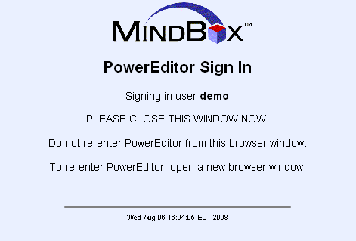

- PE does not fully unlock the category elements when a user cancels, moves on to edit another category, or even navigates to a different tab within Power Editor.
- PE locks an entity when a user clicks the edit button but does not release the lock if
  - the user makes no changes to the entity and moves on to edit a new entity. The first entity remains locked.
  - the user invokes the search button while editing the entity
Once the edit button is clicked, navigating to another tab will not unlock the data. The easiest way to resolve a locking issue is to have all users log out of Power Editor, this will clear the any locking issue. In General, the safest way to edit knowledge is to focus on a single element and make sure the save button is clicked before moving to a edit a different knowledge element.

To safeguard against locking issues, it is recommended that users always logout of PowerEditor when they are finished working.

User Interface Changes
To support the assignment of External Enumerations, the user interface for defining column-level enumerated lists has been expanded. See Section 3.1 for further description.

Upgrade Instructions

Upgrading from Version 5.6.0
Please note the components that have changed since PowerEditor 5.6.0:

PE Element | Changed | Notes
Database | No
PowerEditor Configuration XML file | Yes* | Use of the new functionality to define external column enumerations requires a new Element to be defined in the configuration file. See Section 3.
web.xml | No
Domain XML file | No
Parameter XML file | No
MMS Changes | No

Upgrade Procedure
If you are upgrading from PowerEditor 5.6.0 you can simply follow the standard upgrade instructions as outlined the PowerEditor Installation and Customization Guide. Specifically, see Section 4: PowerEditor Server Upgrade Procedures of that document.

To upgrade,
- Update powereditor.war file.
- Update PowereEditorConfiguration.xml (include new sections for external enumerations if used). This is an optional step.
- Start Application Server.

Upgrading From Version 5.5.2 – Version 5.5.4 Build 7
If you are upgrading from PE version 5.5.4 build 7 or earlier but later than or equal to 5.5.2, you must update MMS code, in addition to the changes described above. However, no DB changes are required.
Beginning in 5.5.4 Version 8 PowerEditor generates the argument to 'pe:entity-match' function in a format different than that of previous releases. An MMS code change is required. Please check with the PowerEditor development team to obtain the update.

Upgrading From Versions Older Than 5.5.2
If you are upgrading from PE version older than 5.5.2, please refer to PowerEditor Installation and Customization Guide and upgrading using PowerEditor Import/Export features, replacing the existing database. If replacing the existing database isn't an option, please consult with the PowerEditor development team.

Description of Enhancements

Working With External Enumeration Source
PowerEditor 5.7.0 supports XML files as a source of enumeration values for guideline template columns. Each enumeration source is to be configured in PowerEditorConfiguration.xml. This allows multiple templates to share the same enumeration source. This section describes how to configure enumeration source and provides a typical example of use.

What are External Enumerations
Until Version 5.7, enumerated values had to be defined either in the domain file or manually at the column attribute level. This new functionality allows the definition of enumerated values in an external xml file.

In addition, conditional selection across two template columns is supported by linking two sets of enumerated values – such as State-County. Within PowerEditor it is now possible to select a single enumerated value in one column (independent variable) and have the drop-down/enumerated list of a second column (dependent variable) be limited by the selected value in the first column.

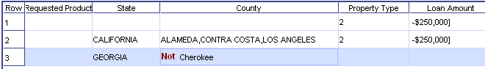

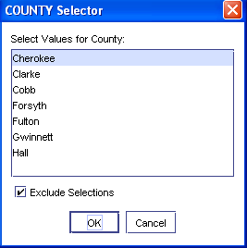

As the above figure shows, in Row 3, the values of County column is limited to Georgia counties because the State column is set to GEORGIA.

Configuration Of Enumeration Source
To configure an XML enumeration source, the following code should be added to the <Server> element within the PowerEditorConfiguration.xml for each enumeration file to be added:

<server>
<EnumerationSources>
<EnumerationSource>
<Type>XML</Type>
<Name>ENTER THE NAME FOR THE ATTRIBUTE</Name>
<SupportsSelector>false</SupportsSelector>
<Param name="xml-file" value="ENTER THE FILE NAME"/>
</EnumerationSource>
</EnumerationSources>
</server>

Notes:
- The <Name> element is used to identify the enumeration source in PowerEditor UI (See the figures on Page 8).
- The <SupportsSelector> element is used to denote an enumeration source which contains a conditional relationship (such as county as a function of state). This should be set to “TRUE” if the conditional selection is needed; “FALSE” otherwise. See section 3.2.3 below for an example of how this is configured for State and County Files.

NOTE: When using a conditional enumeration source, the independent column attribute should be defined in PowerEditor as a Single Select Column – Leave the “Select Multiple” check box UNCHECKED. Only one enumerated value should be selected for this column attribute.

This functionality is set up to support a ONE-to-MANY relationship between the independent and dependent attributes. Selecting multiple enumerated values for the independent attribute will not work in PowerEditor.

Format of Enumeration XML Files
The XML file that contains the enumerated list must conform to the following XML Schema:

<?xml version="1.0" encoding="utf-8"?>
<xsd:schema xmlns:xsd="http://www.w3.org/2001/XMLSchema" elementFormDefault="qualified">
<xsd:element name="PowerEditorEnumeration">
<xsd:complexType>
<xsd:sequence>
<xsd:element name="EnumValue" type="EnumValueType" minOccurs="1" maxOccurs="unbounded" />
</xsd:sequence>
</xsd:complexType>
</xsd:element>
<xsd:complexType name="EnumValueType">
<xsd:sequence>
<!-- Value stored in PE KB and used in generated rules. -->
<xsd:element name="Value" type="xsd:string" minOccurs="1" maxOccurs="1" />
<!-- Value displayed in UI for user selection. -->
<xsd:element name="DisplayLabel" type="xsd:string" minOccurs="0" />
<!-- Indicates if this enum is inactive. -->
<xsd:element name="Inactive" type="xsd:boolean" minOccurs="0" />
<!-- Selector value for this enuemration value.
This is required if selector is supported. -->
<xsd:element name="SelectorValue" type="xsd:string" minOccurs="0" />
</xsd:sequence>
</xsd:complexType>
</xsd:schema>

Using External Enumerations for Supporting State and County Selection
To use the external enumeration enhancement to support Geographic Data (state and county) columns.
- Configure State Enumeration Source in PowerEditorConfiguration.xml.
- Configure County Enumeration Source in PowerEditorConfiguration.xml.
- For each template that needs country, add a state column and a county column of type EnumList.
  - State Column – Since this is the independent variable, define as an enumerated value with an EXTERNAL enumeration source. Leave the “Select Multiple” checkbox UNCHECKED. Set the Enumeration Source dropdown to “States” and leave the Selector Column drop down box empty.
  - County Column – Since this is the dependent variable, define as an enumerated value with an EXTERNAL enumeration source. Check the “Select Multiple” checkbox. Set the Enumeration Source dropdown to “Counties” and set the Selector Column drop down box to States(1).
- Complete Template rule by using the state and county column as you would use any other EnumList column.

Configuring External Enumerations in PowerEditor
In PowerEditor, the external enumeration functionality is invoked within the template-level column definitions. When a column variable is assigned type = EnumList, PowerEditor will now support defining the Enumeration Type as “EXTERNAL” and two additional combo boxes will appear on the interface
- Enumeration Source: This is the source defined in the PE Configuration file through the <Name> element.
- Selector Column: For conditional enumerations, this field is used to identify the column containing the conditional field.
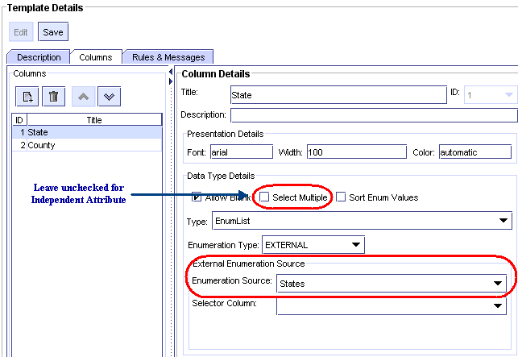

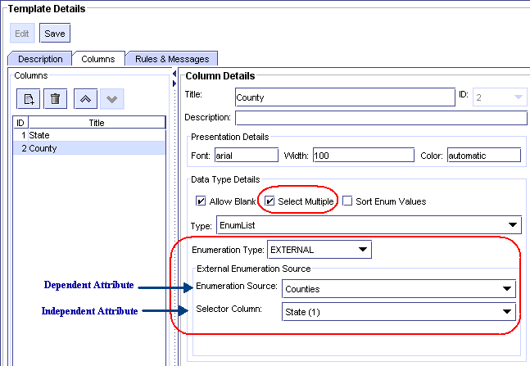

Sample Enumeration XML File - States
Here is a sample state enumeration XML:

<!-- State -->
<PowerEditorEnumeration>
<EnumValue>
<Value>GA</Value>
<DisplayLabel>Georgia</DisplayLabel>
</EnumValue>
<EnumValue>
<Value>VA</Value>
<DisplayLabel>Virginia</DisplayLabel>
</EnumValue>
</PowerEditorEnumeration>

Sample Enumeration XML File – Counties by State
Here is a sample county enumeration XML:

<PowerEditorEnumeration>
<EnumValue>
<Value>forsyth</Value>
<DisplayLabel>Forsyth</DisplayLabel>
<SelectorValue>GA</SelectorValue>
</EnumValue>
<EnumValue>
<Value>fulton</Value>
<DisplayLabel>Fulton</DisplayLabel>
<SelectorValue>GA</SelectorValue>
<Inactive>true</Inactive>
</EnumValue>
</PowerEditorEnumeration>

Configured in the PE Configuration File
This is how the state and county external enumerations are added to the PE Configuration file.

<server>
...
<EnumerationSources>
<EnumerationSource>
<Type>XML</Type>
<Name>States</Name>
<SupportsSelector>false</SupportsSelector>
<Param name="xml-file" value="state-enumeration.xml"/>
</EnumerationSource>
<EnumerationSource>
<Type>XML</Type>
<Name>Counties</Name>
<SupportsSelector>true</SupportsSelector>
<Param name="xml-file" value="county-enumeration.xml"/>
</EnumerationSource>
</EnumerationSources>
</server>

Post Deploy Script Enhancement
PowerEditor now passes deploy status and deploy directory to post deploy scripts. PowerEditor passes them both as command line arguments and as environment variables. The following table summaries data passed to post deploy scripts.

Data | Command Line Argument Position | Environment Variable Name
The deploy status the user specified for deployment. | 1 | KB_STATUS
The full path of the deployment directory. This will include time stamp if use of time stamp is turned on. | 2 | DEPLOY_DIR

XML Schema
XML Schema file for PowerEditorConfiguration.xml is now provided with the PowerEditor distribution file. The XML Schema file is contained in the PowerEditor war file and serves as a definition for the XML structure that is legal in the PowerEditorConfiguration.xml file.

Issues Addressed in Version 5.7

PE should escape double quotes in string columns
If a string column of a guideline grid contains a double quote (“), the previous version of PE would incorrectly not escape the double quote in the generated rule. The proper rule syntax is to generate a double quote with a forward slash character (\”). This has been corrected in Version 5.7

Incorrect deployment in previous versions of Power Editor:
(define-rule
...
==>
(pe-function
:message "..."
:program-name "Product "A" Program")
)

Corrected deployment in Version 5.7:
(define-rule
...
==>
(pe-function
:message "..."
:program-name "Product \"A\" Program")
)

Template remains locked after log off
In the previous version of PowerEditor, user-level template locks remain even though that user is no longer editing the template in question. The lock also remains even after the user closes out of PE altogether. In version 5.7, template locks are released if the user chooses a different template or logs out of PE.

Use '=' instead of 'eq' for numeric values in LHS
For conditions with a equals operator and numeric attribute in LHS, version 5.7 now deploys rules with an equals sign ('='), not the 'eq' operator.

Deployment pattern in Previous versions of Power Editor:
(define-rule
...
(object ?calculation
(instance-of ldo:calculation)
(ldo:CLTV ?cltv &:(eq ?cltv 70.25)))
==>
...
)

Modified deployment pattern in Version 5.7:
(define-rule
...
(object ?calculation
(instance-of ldo:calculation)
(ldo:CLTV ?cltv &:(= ?cltv 70.25)))
==>
...
)

Conditions with enum attribute and non-enum column are deployed incorrectly.
In the previous version of PowerEditor, if a template has a condition with a domain attribute with enumeration values and the value of the condition is not set to a EnumList column, PowerEditor does not deploy the value in the generate pattern. That is, a pattern that matches on all values is generated, instead of one that matches on specified values.

For example, assume that a template A has a condition that reads [Manual Program : Program Code] = 'Column 2'. And, Column 2 of Template A is defined as a symbol column. The 'Program Code' domain attribute has enumeration values. And, a grid for this template has 'CELL-VALUE' in column 2. Then, the previous version of PE would generate for this condition:
(define-rule
...
(object ?manual-program
(instance-of ldo:manual-program)
(ldo:programCode ?programcode))
==>
...
)

Version 5.7 would generate:
(define-rule
...
(object ?manual-program
(instance-of ldo:manual-program)
(ldo:programCode ?programcode &:(eq ?programcode CELL-VALUE)))
==>
...
)

PE should escape percentage signs ('%') in rule names.
In the previous version of PowerEditor, if the name of a template contains the percent character (%) it was deployed incorrectly as a single character. This was corrected in Version 5.7 to correctly deploy with two percent characters (%%)

Incorrect deployment in previous Power Editor Version
(define-rule
...
==>
(pe-function
:message "..."
:rule-name "Programs LTV 0-60%")
)

Corrected deployment in Version 5.7:
(define-rule
...
==>
(pe-function
:message "..."
:rule-name "Program LTV 0-60%%")
)

